**GROWTH ASSESSMENT ANALYSIS OF CHILDREN IN DELTA STATE AND COMPARISON WITH THE CDC GROWTH**

***NB: This analysis was carried out using IBM SPSS and presented in MS Word***

The objectives of the study are to:

1. determine the weight-for-age in males and females;
2. ascertain the height-for-age in males and females;
3. determine the BMI-for-age in males and females;
4. compare weight-for-age, height-for-age and BMI-for-age with the respective CDC growth charts;
5. determine the correlation between HC-for-age and weight-for-age, height-for-age and BMI-for-age in males and females.
6. develop a suitable growth assessment standard of the subjects in this region

The results of the growth parameters which include body weight, body height, head circumference (HC) and body mass index (BMI), age and gender are presented as well as the research questions and hypotheses formulated for the study.

**4.1 Presentation of Results**

A total of one thousand one hundred and seventy nine (1,179) subjects (male = 629, female = 550) participated in this study.

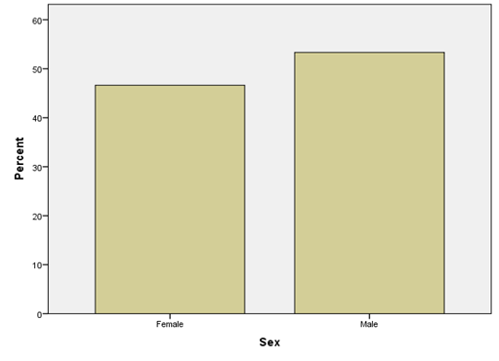

**Distribution of the study subjects based on gender**

**Table 4.1: Descriptive statistics of weight, height and BMI in each age group in females**

|  |  |  |  |  |  |  |  |
| --- | --- | --- | --- | --- | --- | --- | --- |
| Sex | Age(years) | Parameters | N | Minimum | Maximum | Mean | Std. Deviation |
| Female | 5-6 | Weight (kg) | 58.00 | 14.20 | 32.90 | 20.22 | 3.61 |
|  |  | Height (m) | 58.00 | 1.03 | 1.33 | 1.19 | 0.07 |
|  |  | BMI (kg/msq) | 58.00 | 12.08 | 20.08 | 14.26 | 1.60 |
|  | 7-8 | Weight (kg) | 54.00 | 15.70 | 41.50 | 23.04 | 4.83 |
|  |  | Height (m) | 54.00 | 1.05 | 1.52 | 1.27 | 0.09 |
|  |  | BMI (kg/msq) | 54.00 | 11.71 | 19.47 | 14.29 | 1.61 |
|  | 9-10 | Weight (kg) | 64.00 | 16.00 | 50.50 | 28.48 | 7.70 |
|  |  | Height (m) | 64.00 | 1.16 | 1.65 | 1.36 | 0.11 |
|  |  | BMI (kg/msq) | 64.00 | 11.49 | 22.01 | 15.14 | 2.13 |
|  | 11-12 | Weight (kg) | 134.00 | 20.20 | 71.40 | 36.70 | 8.49 |
|  |  | Height (m) | 134.00 | 1.16 | 1.63 | 1.47 | 0.09 |
|  |  | BMI (kg/msq) | 134.00 | 12.55 | 38.64 | 16.96 | 3.52 |
|  | 13-14 | Weight (kg) | 124.00 | 26.30 | 79.00 | 43.42 | 10.18 |
|  |  | Height (m) | 124.00 | 1.16 | 1.88 | 1.57 | 0.09 |
|  |  | BMI (kg/msq) | 124.00 | 10.81 | 58.71 | 17.69 | 4.77 |
|  | 15-17 | Weight (kg) | 116.00 | 31.20 | 74.60 | 50.32 | 10.11 |
|  |  | Height (m) | 116.00 | 1.15 | 1.75 | 1.61 | 0.09 |
|  |  | BMI (kg/msq) | 116.00 | 13.10 | 39.39 | 19.54 | 3.98 |

The descriptive statistics of weight, height and body mass index in each age group in females are shown in Table 4.1. There was a marked increase in the mean values of height, weight and BMI with increase in the age of the female subjects.

**Table 4.2: Descriptive statistics of weight, height and BMI in each age group in males**

|  |  |  |  |  |  |  |  |
| --- | --- | --- | --- | --- | --- | --- | --- |
| Sex | Age(years) | Parameters | N | Minimum | Maximum | Mean | Std. Deviation |
| Male | 5-6 | Weight (kg) | 60.00 | 14.80 | 32.90 | 21.14 | 3.69 |
|  |  | Height (m) | 60.00 | 1.00 | 1.58 | 1.21 | 0.09 |
|  |  | BMI (kg/msq) | 60.00 | 5.93 | 20.08 | 14.52 | 2.11 |
|  | 7-8 | Weight (kg) | 59.00 | 15.20 | 31.40 | 22.89 | 3.61 |
|  |  | Height (m) | 59.00 | 1.10 | 1.46 | 1.25 | 0.08 |
|  |  | BMI (kg/msq) | 59.00 | 12.56 | 20.39 | 14.58 | 1.28 |
|  | 9-10 | Weight (kg) | 80.00 | 18.90 | 63.40 | 28.29 | 7.75 |
|  |  | Height (m) | 80.00 | 1.12 | 1.64 | 1.36 | 0.11 |
|  |  | BMI (kg/msq) | 80.00 | 11.60 | 30.15 | 15.16 | 2.65 |
|  | 11-12 | Weight (kg) | 132.00 | 21.40 | 62.80 | 34.43 | 7.57 |
|  |  | Height (m) | 132.00 | 1.22 | 1.76 | 1.46 | 0.10 |
|  |  | BMI (kg/msq) | 132.00 | 11.35 | 25.48 | 15.92 | 2.07 |
|  | 13-14 | Weight (kg) | 150.00 | 23.60 | 74.50 | 40.96 | 10.21 |
|  |  | Height (m) | 150.00 | 1.27 | 1.81 | 1.55 | 0.11 |
|  |  | BMI (kg/msq) | 150.00 | 10.44 | 26.17 | 16.79 | 2.70 |
|  | 15-17 | Weight (kg) | 148.00 | 26.10 | 82.60 | 48.91 | 11.01 |
|  |  | Height (m) | 148.00 | 1.16 | 1.96 | 1.65 | 0.11 |
|  |  | BMI (kg/msq) | 148.00 | 11.38 | 30.62 | 17.77 | 2.92 |

The descriptive statistics of weight, height and body mass index in each age group in males are shown in Table 4.2. There was a marked increase in the mean values of height, weight and BMI with increase in the age of the male subjects.

Comparison of these anthropometric parameters between male and female subjects showed age-specific differences in favour of the female subjects.

**Fig 3:** Mean BMI-for-age in reference to BMI-for-age percentiles based on CDC growth chart

The chart above represents comparison between CDC growth chart and the mean BMI of the male subjects

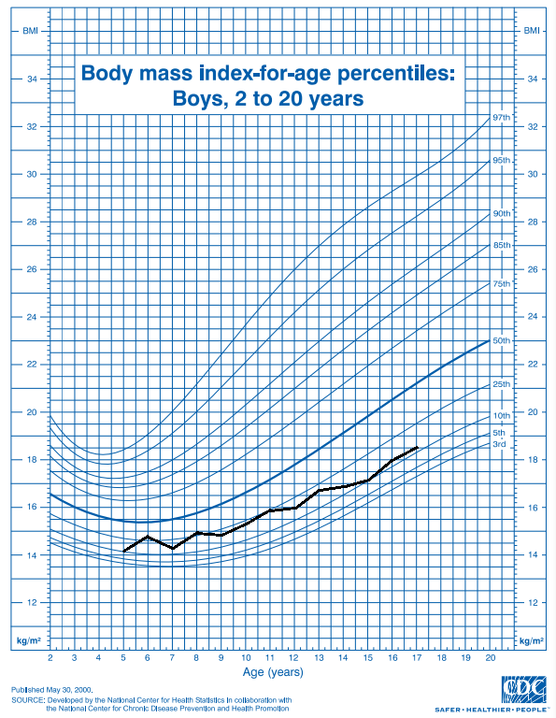

**Fig 4:** Mean height-for-age in reference to height-for-age percentiles based on CDC growth chart

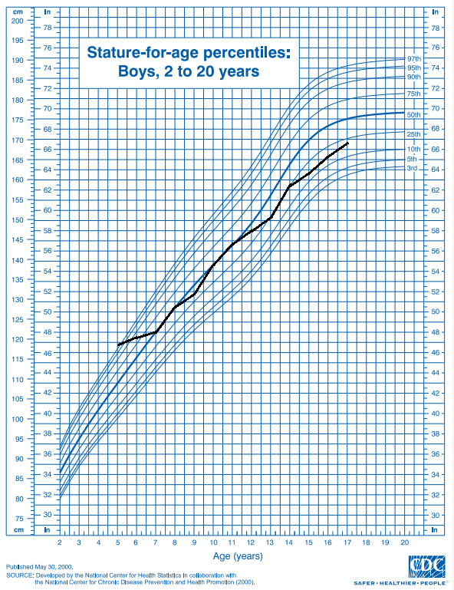

The chart above represents comparison between CDC growth chart and the mean height of the male subjects

**Fig 5:** Mean weight-for-age in reference to weight-for-age percentiles based on CDC growth chart

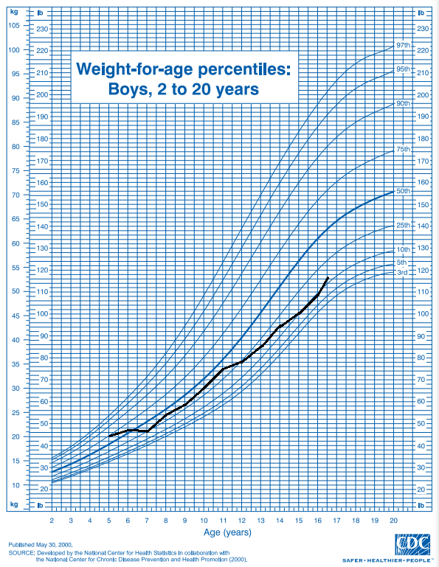

The chart above represents comparison between CDC growth chart and the mean weight of the male subjects

**Fig 6:** Mean BMI-for-age in reference to BMI-for-age percentiles based on CDC growth chart

The chart above represents comparison between CDC growth chart and the mean BMI of the female subjects

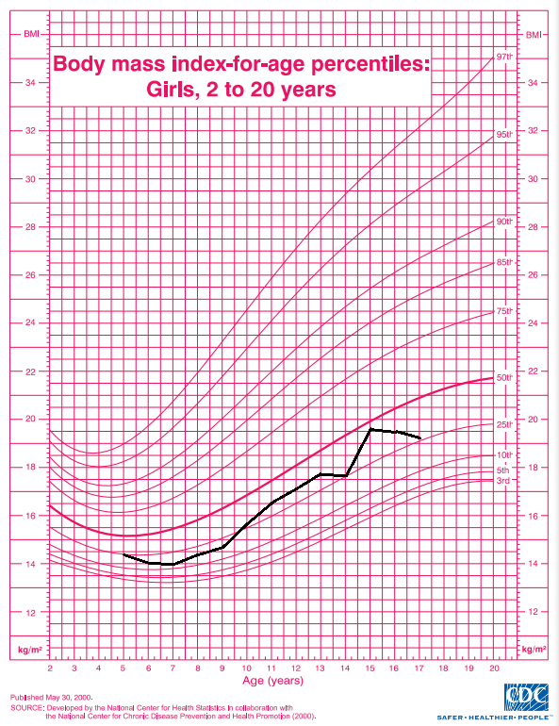

**Fig 7:** Mean height-for-age in reference to height-for-age percentiles based on CDC growth chart

The chart above represents comparison between CDC growth chart and the mean height of the female subjects

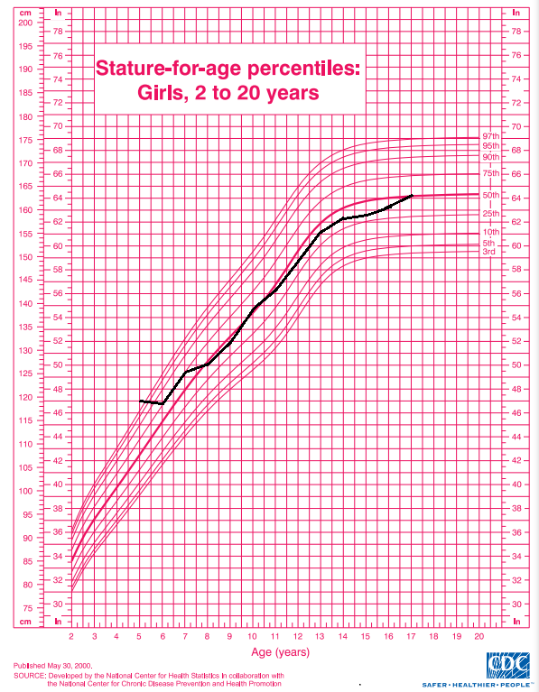

**Fig 8:** Relation between the mean values of body weight in female subjects and the CDC growth chart

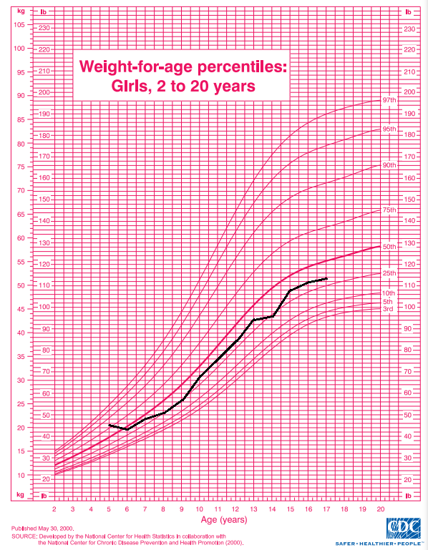

The chart above represents comparison between CDC growth chart and the mean weight of the female subjects

**Fig 9: Correlation between head circumference and age in male subjects**

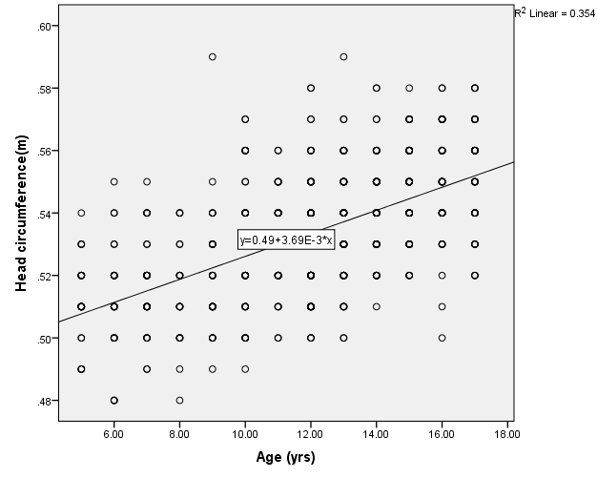

The graph above represents the results of correlation coefficient between the head circumference and age in the male subjects. There was a strong and significant correlation (r=0.60, p <0.001) between head circumference and age in male subjects.

**Fig 10: Correlation between head circumference and weight in male subjects**

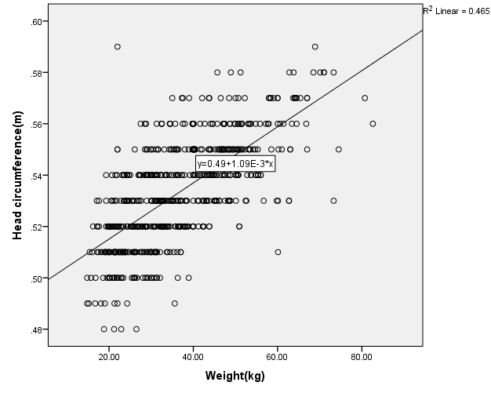

The graph above represents the results of correlation coefficient between the head circumference and weight in the male subjects. There was a strong and significant correlation (r=0.68, p <0.001) between head circumference and weight in male subjects.

**Fig 11: Correlation between head circumference and weight in male subjects**

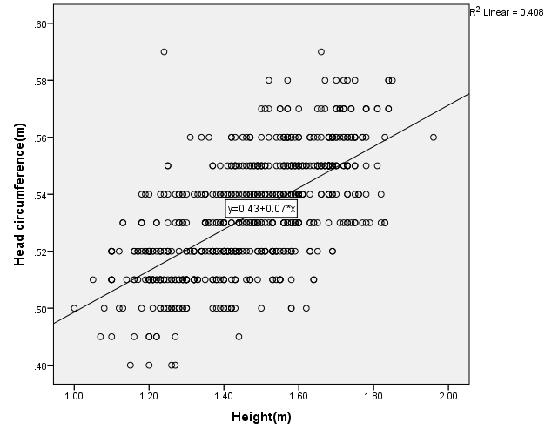

The graph above represents the results of correlation coefficient between the head circumference and height in the male subjects. There was a strong and significant correlation (r=0.64, p <0.001) between head circumference and height in male subjects.

**Fig 12: Correlation between head circumference and bmi in male subjects**

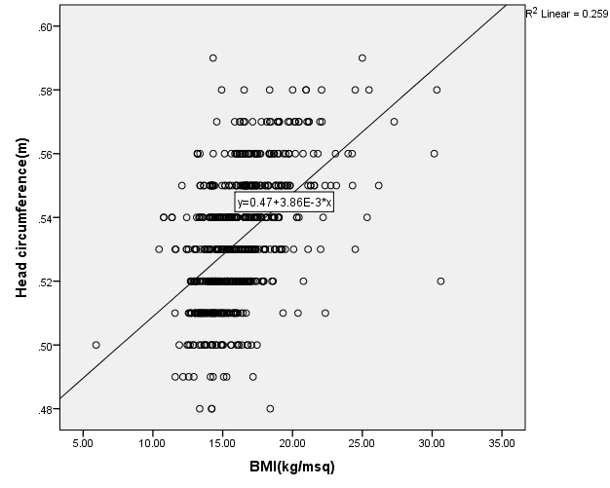

The graph above represents the results of correlation coefficient between the head circumference and BMI in the male subjects. There was a strong and significant correlation (r=0.51, p <0.001) between head circumference and BMI in male subjects.

**Fig 13: Correlation between head circumference and age in female subjects**

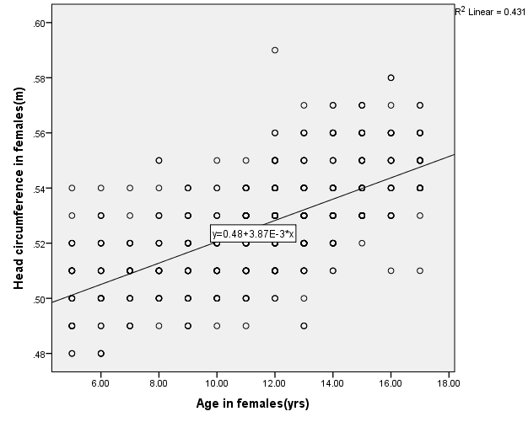

The graph above represents the results of correlation coefficient between the head circumference and age in female subjects. There was a strong and significant correlation (r=0.66, p <0.001) between head circumference and age in female subjects.

**Fig 14: Correlation between head circumference and weight in female subjects**

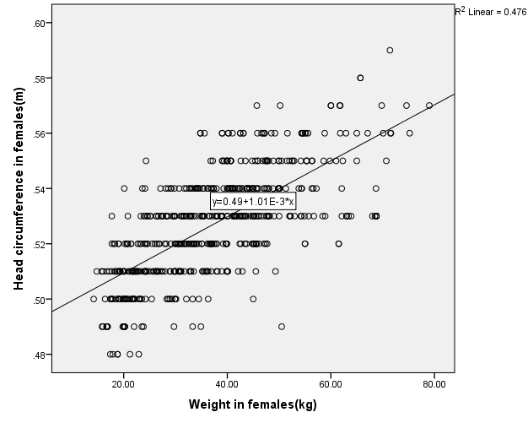

The graph above represents the results of correlation coefficient between the head circumference and age in female subjects. There was a strong and significant correlation (r=0.69, p <0.001) between head circumference and weight in female subjects.

**Fig 15: Correlation between head circumference and height in female subjects**

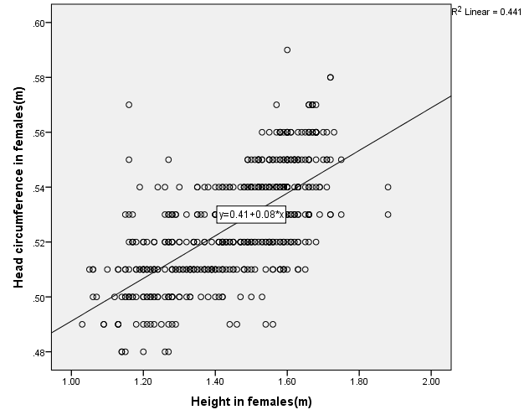

The graph above represents the results of correlation coefficient between the head circumference and height in the female subjects. A strong and significant correlation (r=0.66, p <0.001) between head circumference and height in female subjects.

**Fig 16: Correlation between head circumference and bmi in female subjects**

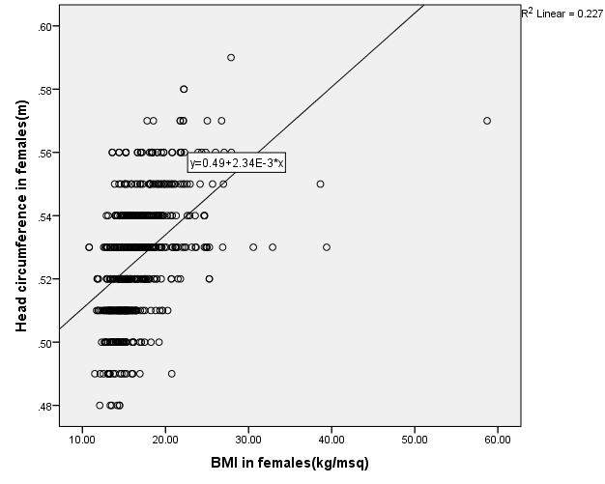

The graph above represents the results of correlation coefficient between the head circumference and BMI in the female subjects. A low and significant correlation (r=0.48, p <0.001) between head circumference and BMI in female subjects.

**Table 4.3: Comparison of weight-for-age between male and female subjects**

|  |  |  |  |  |  |  |  |
| --- | --- | --- | --- | --- | --- | --- | --- |
| **Age (Years)** | **Gender** | **N** | **Mean Body Weight (Kg)** | **Std. Deviation** | **t** | **Df** | **P-Value** |
| 5-6 | male | 60 | 21.14 | 3.69 | 1.377 | 116 | 0.17 |
| female | 58 | 20.22 | 3.61 |
| 7-8 | male | 59 | 22.89 | 3.61 | -0.183 | 111 | 0.86 |
| female | 54 | 23.04 | 4.83 |
| 9-10 | male | 80 | 28.29 | 7.75 | -0.144 | 142 | 0.87 |
| female | 64 | 28.48 | 7.70 |
| 11-12 | male | 132 | 34.43 | 7.57 | -2.310 | 264 | 0.02 |
| female | 134 | 36.70 | 8.49 |
| 13-14 | male | 150 | 40.96 | 10.21 | -1.986 | 272 | 0.05 |
| female | 124 | 43.42 | 10.18 |
| 15-17 | male | 148 | 48.91 | 11.01 | -1.068 | 262 | 0.29 |
| female | 116 | 50.32 | 10.11 |

t = value of t-test Df = degree of freedom

**Table 4.4: Comparison of height-for-age between male and female subjects**

|  |  |  |  |  |  |  |  |
| --- | --- | --- | --- | --- | --- | --- | --- |
| **Age(Years)** | **Gender** | **N** | **Mean Body Height (M)** | **Std. Deviation** | **t** | **Df** | **P-Value** |
| 5-6 | male | 60 | 1.21 | 0.09 | 1.404 | 116 | 0.16 |
| female | 58 | 1.19 | 0.07 |
| 7-8 | male | 59 | 1.25 | 0.08 | -0.960 | 111 | 0.34 |
| female | 54 | 1.27 | 0.09 |
| 9-10 | male | 80 | 1.36 | 0.11 | -0.133 | 142 | 0.90 |
| female | 64 | 1.36 | 0.11 |
| 11-12 | male | 132 | 1.46 | 0.10 | -0.435 | 264 | 0.66 |
| female | 134 | 1.47 | 0.09 |
| 13-14 | male | 150 | 1.55 | 0.11 | -1.184 | 272 | 0.24 |
| female | 124 | 1.57 | 0.09 |
| 15-17 | male | 148 | 1.65 | 0.11 | 3.550 | 262 | <0.001 |
| female | 116 | 1.61 | 0.09 |

t = value of t-test Df = degree of freedom

**Table 4.5: Comparison of BMI-for-age between male and female subjects**

|  |  |  |  |  |  |  |  |
| --- | --- | --- | --- | --- | --- | --- | --- |
| **Age(Years)** | **Gender** | **N** | **Mean Bmi (Kg/Msq)** | **Std. Deviation** | **t** | **Df** | **P-Value** |
| 5-6 | male | 60 | 14.52 | 2.11 | 0.741 | 116 | 0.46 |
| female | 58 | 14.26 | 1.60 |
| 7-8 | male | 59 | 14.58 | 1.28 | 1.082 | 111 | 0.28 |
| female | 54 | 14.29 | 1.61 |
| 9-10 | male | 80 | 15.16 | 2.65 | 0.050 | 142 | 0.96 |
| female | 64 | 15.14 | 2.13 |
| 11-12 | male | 132 | 15.92 | 2.07 | -2.933 | 264 | 0.004 |
| female | 134 | 16.96 | 3.52 |
| 13-14 | male | 150 | 16.79 | 2.70 | -1.972 | 272 | 0.05 |
| female | 124 | 17.69 | 4.77 |
| 15-17 | male | 148 | 17.77 | 2.92 | -4.159 | 262 | <0.001 |
| female | 116 | 19.54 | 3.98 |

t = value of t-test Df = degree of freedom

**Age and sex specific percentiles for growth assessment parameters**

Age and sex specific percentiles for the anthropometric parameters that are commonly used for assessment of the growth and nutritional status in children, such as: weight-for-age, height-for-age and BMI-for-age are shown below.

**Table 4.6 Percentile Values for Weight-for-age, Height-for-age and BMI-for-age in Five (5) Year Old Subjects**

|  |  |  |  |  |  |  |  |  |  |  |  |  |  |  |  |  |  |  |  |  |  |
| --- | --- | --- | --- | --- | --- | --- | --- | --- | --- | --- | --- | --- | --- | --- | --- | --- | --- | --- | --- | --- | --- |
| **Weight-for-age** | | | |  |  | | | | | | | | | | | | | | | | |
|  | | | |  | **Percentiles** | | | | | | | | | | | | | | | | |
| **Sex** | **n** | | **5** | | | | | **15** | **10** | **25** | | **50** | | **75** | | **85** | | **90** | | **95** | |
| Male | 30 | 14.80 | | | | 15.90 | | | 15.43 | 17.20 | | 20.80 | | 22.05 | | 24.60 | | 26.58 | | 29.37 | |
| Female | 30 | 15.30 | | | | 16.75 | | | 16.00 | 17.60 | | 19.80 | | 24.10 | | 24.60 | | 26.80 | | 29.40 | |
|  | |  | | **Height- for -age** | | | | | | | | | | | | | | | | | | |  |
| Male | 30 | | | 106.10 | | | 110.00 | | 108.20 | | 115.00 | | 120.00 | | 123.25 | | 126.70 | | 129.80 | | 143.70 | |
| Female | 30 | | | 104.50 | | | 110.00 | | 106.00 | | 114.00 | | 120.00 | | 125.00 | | 126.70 | | 132.00 | | 133.00 | |

**BMI-for-age**

|  |  |  |  |  |  |  |  |  |  |  |
| --- | --- | --- | --- | --- | --- | --- | --- | --- | --- | --- |
| Male | 30 | 9.04 | 11.65 | 12.53 | 13.29 | 14.42 | 15.28 | 16.40 | 17.17 | 18.93 |
| female | 30 | 12.77 | 12.93 | 13.04 | 13.16 | 14.24 | 14.99 | 15.71 | 17.22 | 18.96 |

**Table 4.7 Percentile Values for Weight-for-age, Height-for-age and BMI-for-age in Six (6) Year Old Subjects**

|  |  |  |  |  |  |  |  |  |  |  |
| --- | --- | --- | --- | --- | --- | --- | --- | --- | --- | --- |
| **Weight-for-age** | |  |  |  |  |  |  |  |  |  |
|  |  |  |  |  | **Percentiles** |  |  |  |  |  |
| **Sex** | **N** | **5** | **10** | **15** | **25** | **50** | **75** | **85** | **90** | **95** |
| Male | 30 | 16.53 | 17.31 | 18.82 | 20.05 | 21.40 | 23.90 | 25.28 | 26.43 | 29.44 |
| Female | 29 | 15.30 | 16.70 | 17.30 | 17.80 | 19.30 | 20.85 | 21.40 | 21.80 | 27.90 |
|  |  |  |  |  | **Height-for-age** |  |  |  |  |  |
| Male | 30 | 105.50 | 110.00 | 110.00 | 119.50 | 123.00 | 126.25 | 128.70 | 131.80 | 132.45 |
| Female | 29 | 106.50 | 109.00 | 111.00 | 115.00 | 117.00 | 122.00 | 126.50 | 127.00 | 130.50 |
|  |  |  |  |  | **BMI-for-age** |  |  |  |  |  |
| Male | 30 | 12.51 | 12.71 | 13.24 | 13.44 | 14.21 | 15.56 | 16.85 | 17.04 | 19.16 |
| Female | 29 | 12.20 | 12.64 | 12.80 | 13.17 | 13.732 | 14.56 | 15.20 | 15.90 | 18.50 |

**Table 4.8 Percentile Values for Weight-for-age, Height-for-age and BMI-for-age in Seven (7) Year Old Subjects**

|  |  |  |  |  |  |  |  |  |  |  |
| --- | --- | --- | --- | --- | --- | --- | --- | --- | --- | --- |
| **Weight-for-age** | |  |  |  |  |  |  |  |  |  |
|  |  |  |  |  | **Percentiles** |  |  |  |  |  |
| **Sex** | **N** | **5** | **10** | **15** | **25** | **50** | **75** | **85** | **90** | **95** |
| Male | 34 | 16.63 | 17.60 | 18.70 | 19.75 | 21.30 | 22.93 | 25.48 | 26.20 | 28.00 |
| Female | 25 | 16.00 | 17.66 | 18.75 | 19.15 | 20.60 | 23.55 | 24.80 | 28.58 | 38.11 |
|  |  |  |  |  | **Height-for-age** |  |  |  |  |  |
| Male | 34 | 110.00 | 113.00 | 114.50 | 119.75 | 122.00 | 125.25 | 129.75 | 131.50 | 132.00 |
| Female | 25 | 113.00 | 114.20 | 115.00 | 119.50 | 125.00 | 129.50 | 134.10 | 135.80 | 143.30 |
|  |  |  |  |  | **BMI-for-age** |  |  |  |  |  |
| Male | 34 | 12.7082 | 12.9972 | 13.4368 | 13.6524 | 14.3107 | 14.9292 | 15.2525 | 15.7608 | 16.3896 |
| Female | 25 | 11.8141 | 11.8964 | 12.0748 | 12.6447 | 13.4431 | 14.9853 | 15.4161 | 16.9423 | 18.9892 |

**Table 4.9 Percentile Values for Weight-for-age, Height-for-age and BMI-for-age in Eight (8) Year Old Subjects**

|  |  |  |  |  |  |  |  |  |  |  |
| --- | --- | --- | --- | --- | --- | --- | --- | --- | --- | --- |
| **Weight-for-age** |  |  |  |  |  |  |  |  |  |  |
|  |  |  |  |  | **Percentiles** |  |  |  |  |  |
| **Sex** | **N** | **5** | **10** | **15** | **25** | **50** | **75** | **85** | **90** | **95** |
| Male | 25 | 18.86 | 19.72 | 20.74 | 22.15 | 24.30 | 26.80 | 30.16 | 30.70 | 31.19 |
| Female | 29 | 18.35 | 19.30 | 19.90 | 21.40 | 22.70 | 24.70 | 28.20 | 30.80 | 36.00 |
|  |  |  |  |  | **Height-for-age** |  |  |  |  |  |
| Male | 25 | 114.30 | 115.60 | 116.00 | 124.00 | 130.00 | 135.00 | 138.20 | 140.40 | 1440 |
| Female | 29 | 109.50 | 118.00 | 120.50 | 121.00 | 128.00 | 133.00 | 138.50 | 142.00 | 1400 |
|  |  |  |  |  | **BMI-for-age** |  |  |  |  |  |
| Male | 25 | 12.78 | 13.12 | 13.36 | 13.85 | 14.85 | 15.65 | 16.08 | 16.31 | 19.18 |
| Female | 29 | 12.15 | 12.88 | 13.26 | 13.65 | 14.48 | 15.14 | 15.76 | 16.92 | 17.39 |

**Table 4.10 Percentile Values for Weight-for-age, Height-for-age and BMI-for-age in Nine (9) Year Old Subjects**

|  |  |  |  |  |  |  |  |  |  |  |
| --- | --- | --- | --- | --- | --- | --- | --- | --- | --- | --- |
| **Weight-for-age** | |  |  |  |  |  |  |  |  |  |
|  |  |  |  |  | **Percentiles** |  |  |  |  |  |
| **Sex** | **N** | **5** | **10** | **15** | **25** | **50** | **75** | **85** | **90** | **95** |
| Male | 34 | 19.13 | 19.40 | 20.33 | 21.75 | 24.15 | 29.15 | 31.43 | 33.90 | 39.03 |
| Female | 35 | 18.00 | 18.84 | 20.08 | 21.80 | 24.20 | 29.90 | 32.80 | 37.36 | 40.78 |
|  |  |  |  |  | **Height-for-age** | |  |  |  |  |
| Male | 34 | 117.75 | 120.50 | 122.25 | 123.75 | 129.00 | 138.50 | 140.75 | 143.00 | 147.00 |
| Female | 35 | 117.60 | 120.60 | 123.00 | 126.00 | 130.00 | 140.00 | 143.00 | 145.40 | 149.20 |
|  |  |  |  |  | **BMI-for-age** | |  |  |  |  |
| Male | 34 | 12.62 | 12.93 | 13.01 | 13.43 | 14.37 | 15.67 | 16.85 | 17.06 | 19.20 |
| Female | 35 | 11.72 | 12.36 | 12.91 | 13.31 | 14.45 | 15.50 | 16.71 | 18.16 | 19.63 |
|  |  |  |  |  |  |  |  |  |  |  |

**Table 4.11 Percentile Values for Weight-for-age, Height-for-age and BMI-for-age in Ten (10) Year Old Subjects**

|  |  |  |  |  |  |  |  |  |  |  |
| --- | --- | --- | --- | --- | --- | --- | --- | --- | --- | --- |
| **Weight-for-age** | |  |  |  |  |  |  |  |  |  |
|  |  |  |  |  | **Percentiles** |  |  |  |  |  |
| **Sex** | **N** | **5** | **10** | **15** | **25** | **50** | **75** | **85** | **90** | **95** |
| Male | 46 | 20.91 | 21.54 | 22.23 | 23.40 | 28.85 | 35.00 | 38.87 | 40.10 | 46.07 |
| Female | 29 | 21.85 | 23.20 | 23.70 | 25.90 | 28.90 | 32.30 | 44.35 | 47.70 | 49.35 |
|  |  |  |  |  | **Height-for-age** |  |  |  |  |  |
| Male | 46 | 121.00 | 124.00 | 127.00 | 128.00 | 141.00 | 147.25 | 149.95 | 151.90 | 156.30 |
| Female | 29 | 123.50 | 126.00 | 127.50 | 132.50 | 141.00 | 146.50 | 151.50 | 156.00 | 162.00 |
|  |  |  |  |  | **BMI-for-age** |  |  |  |  |  |
| Male | 46 | 12.57 | 12.91 | 13.1878 | 13.78 | 14.68 | 16.13 | 16.88 | 17.76 | 21.46 |
| Female | 29 | 13.27 | 13.68 | 14.1514 | 14.30 | 15.03 | 16.16 | 17.98 | 19.22 | 21.38 |

**Table 4.12 Percentile Values for Weight-for-age, Height-for-age and BMI-for-age in Eleven (11) Year Old Subjects**

|  |  |  |  |  |  |  |  |  |  |  |
| --- | --- | --- | --- | --- | --- | --- | --- | --- | --- | --- |
| **Weight-for-age** | |  |  |  |  |  |  |  |  |  |
|  |  |  |  |  | **Percentiles** |  |  |  |  |  |
| **Sex** | **N** | **5** | **10** | **15** | **25** | **50** | **75** | **85** | **90** | **95** |
| Male | 44 | 22.93 | 25.00 | 26.73 | 28.73 | 31.95 | 36.83 | 41.40 | 44.65 | 47.10 |
| Female | 54 | 23.53 | 25.00 | 27.35 | 29.20 | 33.20 | 37.90 | 40.75 | 42.30 | 49.33 |
|  |  |  |  |  | **Height-for-age** | |  |  |  |  |
| Male | 44 | 127.50 | 130.00 | 136.75 | 139.25 | 142.00 | 150.00 | 156.50 | 160.00 | 167.50 |
| Female | 54 | 128.00 | 131.50 | 134.25 | 136.75 | 144.00 | 150.00 | 154.00 | 156.50 | 160.75 |
|  |  |  |  |  | **BMI-for-age** | |  |  |  |  |
| Male | 44 | 13.06 | 13.69 | 14.02 | 14.48 | 15.64 | 16.69 | 17.26 | 17.71 | 18.72 |
| Female | 54 | 13.51 | 13.88 | 13.94 | 14.38 | 15.88 | 17.34 | 17.88 | 18.84 | 25.26 |

**Table 4.13 Percentile Values for Weight-for-age, Height-for-age and BMI-for-age in Twelve (12) Year Old Subjects**

|  |  |  |  |  |  |  |  |  |  |  |
| --- | --- | --- | --- | --- | --- | --- | --- | --- | --- | --- |
| **Weight-for-age** | |  |  |  |  |  |  |  |  |  |
|  |  |  |  | **Percentiles** |  |  |  |  |  |  |
| **Sex** | **N** | **5** | **10** | **15** | **25** | **50** | **75** | **85** | **90** | **95** |
| Male | 88 | 25.59 | 27.52 | 28.44 | 30.00 | 32.90 | 38.00 | 43.67 | 44.77 | 51.31 |
| Female | 80 | 27.53 | 29.21 | 30.60 | 32.78 | 37.25 | 42.58 | 45.09 | 49.99 | 54.52 |
|  |  |  |  | **Height-for-age** | |  |  |  |  |  |
| Male | 88 | 135.00 | 136.90 | 137.35 | 140.00 | 145.00 | 155.00 | 156.65 | 158.00 | 163.00 |
| Female | 80 | 136.05 | 138.10 | 141.00 | 144.00 | 149.00 | 156.00 | 158.00 | 159.00 | 159.95 |
|  |  |  |  | **BMI-for-age** | |  |  |  |  |  |
| Male | 88 | 13.02 | 13.06 | 14.12 | 14.64 | 15.88 | 17.02 | 17.69 | 18.23 | 19.88 |
| Female | 80 | 13.43 | 14.25 | 14.82 | 15.44 | 16.46 | 18.00 | 19.43 | 21.07 | 25.14 |

**Table 4.14 Percentile Values for Weight-for-age, Height-for-age and BMI-for-age in Thirteen (13) Year Old Subjects**

|  |  |  |  |  |  |  |  |  |  |  |  |  |  |  |  |  |  |  |  |  |
| --- | --- | --- | --- | --- | --- | --- | --- | --- | --- | --- | --- | --- | --- | --- | --- | --- | --- | --- | --- | --- |
| **Weight-for-age** | | |  | |  | |  | | |  | |  | |  | |  | |  | |  |
|  |  | |  | |  | | **Percentiles** | | |  | |  | |  | |  | |  | |  |
| **Sex** | | **N** | | **5** | | **10** | | **15** | **25** | | **50** | | **75** | | **85** | | **90** | | **95** | |
| Male | | 77 | | 27.49 | | 28.82 | | 29.90 | 31.25 | | 37.50 | | 44.65 | | 47.50 | | 50.20 | | 59.20 | |
| Female | | 67 | | 29.90 | | 31.48 | | 33.44 | 36.30 | | 41.00 | | 47.60 | | 55.00 | | 57.12 | | 60.52 | |
|  | |  | |  | |  | |  | **Height-for-age** | | | |  | |  | |  | |  | |
| Male | | 77 | | 134.90 | | 138.00 | | 142.00 | 144.00 | | 151.00 | | 160.00 | | 163.00 | | 164.20 | | 168.20 | |
| Female | | 67 | | 142.40 | | 144.00 | | 146.20 | 150.00 | | 157.00 | | 161.00 | | 163.00 | | 165.20 | | 168.60 | |
|  | |  | |  | |  | |  | **BMI-for-age** | | | |  | |  | |  | |  | |
| Male | | 77 | | 13.64 | | 14.05 | | 14.27 | 14.94 | | 16.25 | | 17.38 | | 19.04 | | 19.74 | | 22.42 | |
| Female | | 67 | | 14.04 | | 14.71 | | 15.27 | 15.61 | | 16.90 | | 19.50 | | 20.83 | | 21.55 | | 23.34 | |

**Table 4.15 Percentile Values for Weight-for-age, Height-for-age and BMI-for-age in Fourteen (14) Year Old Subjects**

|  |  |  |  |  |  |  |  |  |  |  |
| --- | --- | --- | --- | --- | --- | --- | --- | --- | --- | --- |
| **Weight-for-age** | |  |  |  |  |  |  |  |  |  |
|  |  |  |  |  | **Percentiles** |  |  |  |  |  |
| **Sex** | **N** | **5** | **10** | **15** | **25** | **50** | **75** | **85** | **90** | **95** |
| Male | 73 | 24.94 | 30.88 | 32.34 | 37.00 | 41.60 | 48.50 | 51.35 | 55.60 | 67.77 |
| Female | 57 | 33.40 | 34.16 | 35.12 | 37.10 | 43.60 | 47.60 | 56.26 | 62.10 | 68.42 |
|  |  |  |  | **Height-for-age** | |  |  |  |  |  |
| Male |  | 136.80 | 145.80 | 147.10 | 150.50 | 160.00 | 168.50 | 171.80 | 173.00 | 175.60 |
| Female |  | 150.00 | 151.00 | 152.00 | 154.00 | 158.00 | 162.00 | 166.00 | 168.00 | 177.200 |
|  |  |  |  | **BMI-for-age** | |  |  |  |  |  |
| Male |  | 12.61 | 14.03 | 14.25 | 15.22 | 16.64 | 17.80 | 19.15 | 21.56 | 23.27 |
| Female |  | 13.47 | 14.11 | 13.53 | 15.86 | 17.23 | 18.62 | 19.82 | 22.25 | 25.57 |

**Table 4.16 Percentile Values for Weight-for-age, Height-for-age and BMI-for-age in Fifteen (15) Year Old Subjects**

|  |  |  |  |  |  |  |  |  |  |  |
| --- | --- | --- | --- | --- | --- | --- | --- | --- | --- | --- |
| **Weight-for-age** | |  |  |  |  |  |  |  |  |  |
|  |  |  |  |  | **Percentiles** |  |  |  |  |  |
| **Sex** | **N** | **5** | **10** | **15** | **25** | **50** | **75** | **85** | **90** | **95** |
| Male | 60 | 30.51 | 32.40 | 32.50 | 36.10 | 44.75 | 51.58 | 59.97 | 62.70 | 63.67 |
| Female | 53 | 32.70 | 36.20 | 39.01 | 42.00 | 47.60 | 54.50 | 63.00 | 68.30 | 68.80 |
|  |  |  |  |  | **Height-for-age** | |  |  |  |  |
| Male | 60 | 143.05 | 147.00 | 147.30 | 155.00 | 160.00 | 170.75 | 176.70 | 181.70 | 183.00 |
| Female | 53 | 149.00 | 153.40 | 157.0 | 155.00 | 160.00 | 167.00 | 168.00 | 171.20 | 172.40 |
|  |  |  |  |  | **BMI-for-age** | |  |  |  |  |
| Male | 60 | 13.19 | 13.32 | 14.33 | 15.16 | 17.30 | 19.00 | 19.77 | 20.20 | 21.11 |
| Female | 53 | 14.53 | 14.83 | 15.35 | 16.51 | 18.98 | 21.53 | 24.84 | 24.97 | 28.81 |

**Table 4.17 Percentile Values for Weight-for-age, Height-for-age and BMI-for-age in Sixteen (16) Year Old Subjects**

|  |  |  |  |  |  |  |  |  |  |  |
| --- | --- | --- | --- | --- | --- | --- | --- | --- | --- | --- |
| **Weight-for-age** |  |  |  |  |  |  |  |  |  |  |
|  |  |  |  |  | **Percentiles** |  |  |  |  |  |
| **Sex** | **N** | **5** | **10** | **15** | **25** | **50** | **75** | **85** | **90** | **95** |
| Male | 50 | 29.42 | 34.43 | 39.60 | 44.80 | 49.65 | 53.18 | 59.38 | 64.18 | 75.37 |
| Female | 31 | 35.16 | 39.00 | 39.00 | 40.20 | 47.70 | 58.60 | 65.70 | 68.10 | 72.80 |
|  |  |  |  |  | **Height-for-age** |  |  |  |  |  |
| Male | 50 | 147.40 | 154.30 | 157.65 | 159.00 | 167.00 | 173.00 | 175.00 | 177.70 | 184.00 |
| Female | 31 | 149.00 | 153.40 | 155.00 | 157.00 | 160.00 | 167.00 | 168.00 | 171.20 | 172.40 |
|  |  |  |  |  | **BMI-for-age** |  |  |  |  |  |
| Male | 50 | 12.18 | 13.80 | 15.04 | 16.47 | 17.50 | 19.18 | 21.02 | 21.47 | 25.00 |
| Female | 31 | 13.89 | 14.58 | 15.23 | 16.14 | 19.48 | 22.21 | 23.74 | 24.12 | 25.48 |

**Table 4.18 Percentile Values for Weight-for-age, Height-for-age and BMI-for-age in Seventeen (17) Year Old Subjects**

|  |  |  |  |  |  |  |  |  |  |  |
| --- | --- | --- | --- | --- | --- | --- | --- | --- | --- | --- |
| **Weight-for-age** | |  |  |  |  |  |  |  |  |  |
|  |  |  |  |  | **Percentiles** |  |  |  |  |  |
| **Sex** | **N** | **5** | **10** | **15** | **25** | **50** | **75** | **85** | **90** | **95** |
| Male | 38 | 36.15 | 36.40 | 45.83 | 48.55 | 52.90 | 60.00 | 64.85 | 67.00 | 68.58 |
| Female | 32 | 40.93 | 41.83 | 42.89 | 45.55 | 50.00 | 56.13 | 56.86 | 67.40 | 70.31 |
|  |  |  |  | **Height-for-age** | |  |  |  |  |  |
| Male |  | 153.90 | 154.00 | 158.85 | 163.00 | 169.50 | 175.00 | 178.00 | 181.00 | 183.10 |
| Female |  | 152.00 | 154.30 | 157.85 | 159.00 | 163.00 | 168.75 | 171.00 | 171.70 | 175.00 |
|  |  |  |  | **BMI-for-age** | |  |  |  |  |  |
| Male |  | 15.20 | 15.3483 | 16.29 | 16.98 | 18.59 | 19.55 | 20.45 | 20.86 | 24.30 |
| Female |  | 14.22 | 15.1172 | 16.32 | 17.39 | 18.92 | 21.16 | 22.93 | 24.45 | 25.25 |